**Smart Water Management system**

**Introduction:**

Smart water management is the activity of planning , developing, distributing and managing the use of water resources using an array of IOT technology .Which are designed to increase transparency and make more reasonable.

**Hardware Components:**

1. Ultrasonic sensor
2. pH sensor
3. Digital thermometer sensor
4. Turbidity sensor
5. RF module.

**Software components:**

1. Git application
2. Visual studio code
3. Programming language (python)

**Design for smart water fountain:**

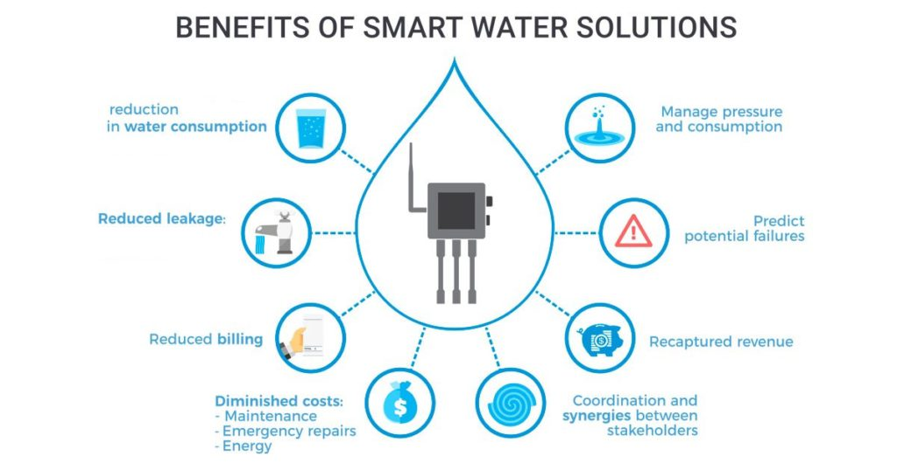

**Conclusion:**

Traditional methods of conservation have been implemented to conserve water but smat device that are leveraging IOT technology is the answer to taking water conservation to a new level.IOT technology will enable smart water meters, sensors and irrigation system to be deployed in homes and businesses with ease.

**Project submitted by,**

* **Name: S.Vishnu priya**
* **Email id:** [**2410vishnupriya@gmail.com**](mailto:2410vishnupriya@gmail.com)
* **Nan mudhalvan I’d: au713921106060**
* **College code:7139**